Project Design Phase-II
Technology Stack (Architecture & Stack)

Date | 09 september 2026
Team ID
Project Name | ServiceNow-Based Employee Laptop Request Application
Maximum Marks | 4 Marks

Technical Architecture:
The Deliverable shall include the architectural diagram as below and the information as per the table1 & table 2
Example: ServiceNow-Based Laptop Request and Approval Management
Reference: https://www.servicenow.com/docs/r/it-service-management/request-management/c_RequestManagement.html

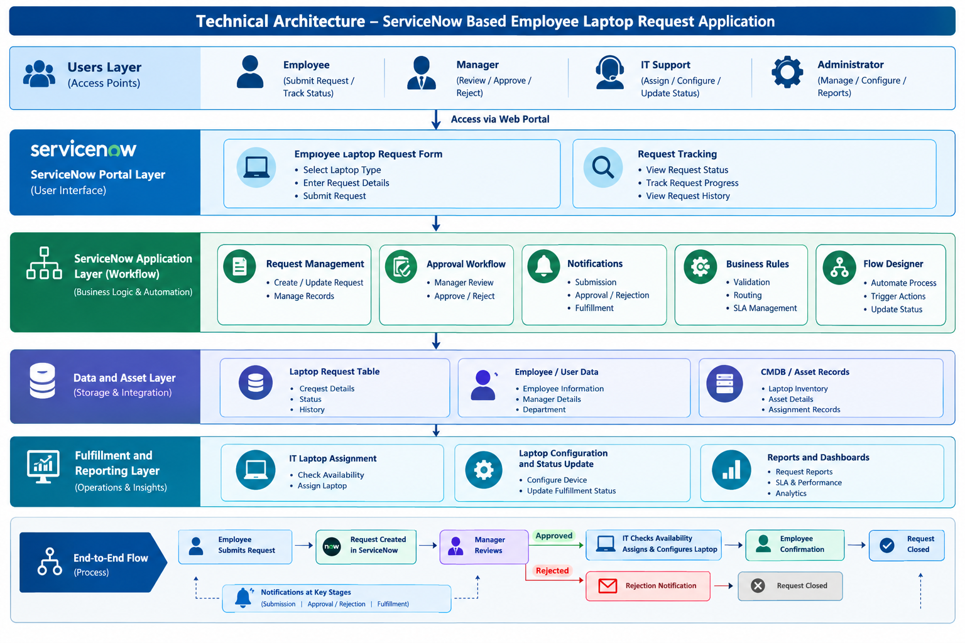Table-1: Components & Technologies
S.No. | Component | Description | Technology
1 | User Interface | Employee laptop request and tracking interface | ServiceNow Employee Center
2 | Request Management | Creates and manages laptop requests | ServiceNow Service Catalog
3 | Approval Workflow | Routes requests to managers for approval/rejection | Flow Designer
4 | Business Logic | Validates and updates request information | Business Rules / Glide Script
5 | Database | Stores employee and request details | ServiceNow Tables
6 | Asset Management | Maintains laptop asset and assignment details | CMDB / Hardware Asset Management
7 | Notifications | Sends request, approval and fulfillment updates | ServiceNow Notifications
8 | Reporting | Monitors requests and fulfillment status | ServiceNow Reports & Dashboards
9 | External API | External integration if required | Not required
10 | Machine Learning | AI/ML processing | Not required
11 | Infrastructure | Hosts and runs the complete application | ServiceNow Cloud Platform
Table-2: Application Characteristics
S.No. | Characteristic | Description | Technology
1 | Open-Source Frameworks | No external framework is required | ServiceNow Platform
2 | Security | Role-based access controls protect requests and approvals | ACL / Roles
3 | Scalability | Supports increasing employees and laptop requests | ServiceNow Cloud
4 | Availability | Centralized cloud platform provides continuous access | ServiceNow Platform
5 | Performance | Automated workflows reduce manual processing time | Flow Designer

References:
https://www.servicenow.com/docs/r/it-service-management/request-management/request-management-architecture.html?utm_source=chatgpt.com
https://www.servicenow.com/docs/r/it-service-management/request-management/c_RequestManagement.html?utm_source=chatgpt.com
https://www.servicenow.com/content/dam/servicenow-assets/public/en-us/doc-type/success/reference-architecture/digital-business-models.pdf?utm_source=chatgpt.com

https://medium.com/the-internal-shttps://blogs.servicenow.com/content/dam/servicenow-assets/public/en-us/doc-type/resource-center/white-paper/wp-cmdb-design-guidance.pdf?utm_source=chatgpt.comtartup/how-to-draw-useful-technical-architecture-diagrams-2d20c9fda90d

